Transferring workspace and jobs of Jenkins to new server

Already created Jenkins workspace 🡪 compressing it in tar.gz form 🡪 storing it in s3 🡪 Creating new server 🡪 downloading that backup from s3 to new EC2 server 🡪 Extracting folder in /var/lib/Jenkins/ folder 🡪 restarting Jenkins by using sudo systemctl restart Jenkins command

Step 1:

**tar -czvf workspace_backup.tar.gz workspace/**

with this command, we will compress the workspace of the old server



Step 2:

We have to create a bucket in s3 to store backup

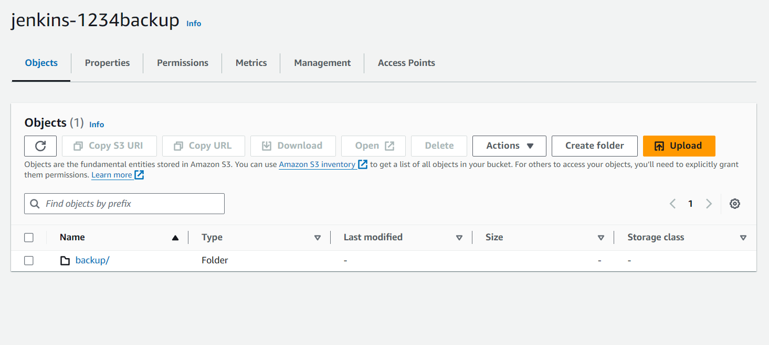

**aws cp /var/lib/jenkins/workspace_backup.tar.gz s3://jenkins-1234backup/backup/**

now with this command, we will copy tar.gz file into our s3

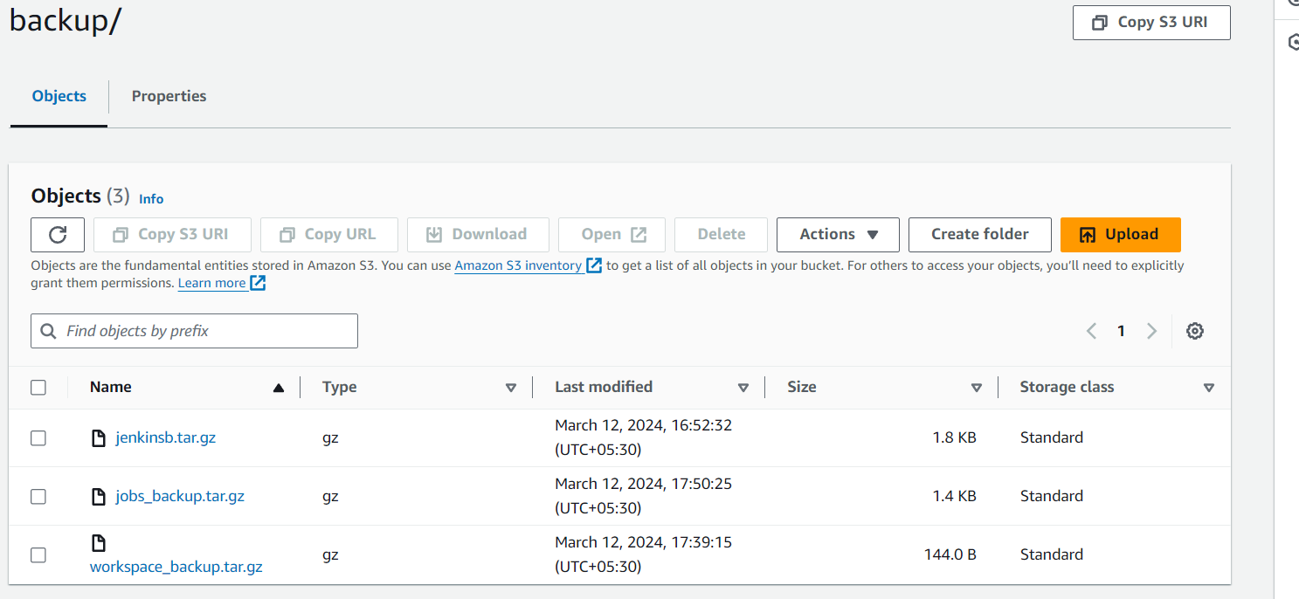

Step 3:

Creating new server which already have Jenkins installed

**sudo aws s3 cp s3://jenkins-1234backup/backup/jobs_backup.tar.gz /var/lib/jenkins/**

now we have our file in our new server

**sudo tar -xzvf /var/lib/jenkins/jobs_backup.tar.gz**

then with this command, we can extract the file

step 4:

after all these steps we have to restart the Jenkins service using **sudo systemctl restart Jenkins**

